***PROJECT:***

***SPORTS MANAGEMENT SYSTEM***

**SOFTWARE ENGINEERING LAB (CE220L)**



***NAME:* SYED MUZAFFAR RAZA**

***ROLL NO.:* 2021F-BCE-057**

***NAME:* M. SHAHEER SHARIF**

***ROLL NO.:* 2021F-BCE- 218**

***NAME:* SHEIKH M HAMZA**

***ROLL NO.:* 2021F-BCE-255**

***SECTION:* B**

***SUBMITTED TO:* MISS SADIA IQBAL**

***DEPARTMENT OF***

**COMPUTER ENGINEERING**

***SIR SYED UNIVERSITY OF ENGINEERING***

***AND TECHNOLOGY***

## **Table of Contents:**

1.Introduction  
   1.1 Purpose  
   1.2 Need/Motivation  
2.Literature survey  
3.Requirements.  
    3.1 Functional Requirements  
    3.2 Non- Functional Requirements  
          3.2.1  Safety Requirements.  
          3.2.2  Security Requirements  
          3.2.3  Software Quality Attributes  
   3.3  Hardware Requirements  
   3.4  Software   
   3.5  VModel  
   3.6 Feasibility Study  
       3.6.1 Economic Feasibility  
       3.6.2 Technical Feasibility  
        3.6.3 Operational Feasibility  
4. System  Architecture  
      4.1 Client-Server Architecture  
5. Design and Implementation  
    5.1  Product  Features  
    5.2  class diagram design  
    5.3 Use case diagram  
    5.4  Sequence diagram  
    5.5  E-R Diagram and Normalisation  
       5.5.1 E-R Normalisation  
6. Snapshots  
7. Conclusion

**Introduction:**

The purpose of this document is to outline the features and functionality of a sports management system developed using PHP and XAMPP. This system aims to centralize data management, enhance communication and collaboration, optimize timestabling, and facilitate examination management in the sports industry. The need for such a system arises from the desire to improve administrative processes, generate comprehensive reporting and analytics, and ensure security and data privacy.

**Need/Motivation:** The sports management system addresses the need for an efficient administrative process in handling sports-related operations. It aims to streamline tasks such as venue reservation, staff management, cost tracking, and communication and collaboration among various stakeholders. The system also provides integration and compatibility with existing systems, ensures security and data privacy, and focuses on usability and user experience. Scalability and flexibility are essential to accommodate the growing needs of the sports organization.

**Functionality and Features:**

The sports management system encompasses various functionalities and features, including but not limited to:

* Venue Reservation: Allow users to reserve sports venues for events, practices, and competitions. The system should provide a comprehensive view of venue availability and enable easy booking.
* Staff Management: Enable administrators to manage staff members' information, roles, and schedules. This includes assigning responsibilities, tracking attendance, and generating staff reports.
* Cost Tracking: Provide a module to monitor and manage financial aspects such as event budgets, expense tracking, and revenue generation. The system should support budget allocation and generate financial reports.
* Communication and Collaboration: Facilitate effective communication and collaboration among administrators, coaches, athletes, and other stakeholders. This includes features like instant messaging, notifications, document sharing, and discussion forums.
* Integration and Compatibility: Ensure seamless integration with other existing systems, such as registration platforms, payment gateways, and external databases. The system should support data exchange and interoperability.
* Security and Data Privacy: Implement robust security measures to protect sensitive data, including user authentication, data encryption, access control, and regular system backups. Compliance with relevant data privacy regulations should be ensured.
* Usability and User Experience: Design an intuitive and user-friendly interface that enables easy navigation and task completion. The system should provide a pleasant user experience and minimize the learning curve for new users.
* Scalability and Flexibility: Develop the system to handle a growing number of users, events, and data. It should be flexible enough to accommodate future enhancements and customizations based on the organization's evolving needs.

**Benefits and Impacts:**

The sports management system offers several benefits and impacts, including:

* Streamlined administrative processes, leading to increased efficiency and productivity.
* Enhanced communication and collaboration among stakeholders, fostering better teamwork and coordination.
* Optimized timestabling, resulting in improved scheduling accuracy and resource utilization.
* Facilitated examination management, ensuring smooth conduct and efficient evaluation of sports-related exams.
* Comprehensive reporting and analytics, providing valuable insights for decision-making and performance evaluation.
* Increased security and data privacy, safeguarding sensitive information and ensuring compliance with regulations.
* Improved user experience and satisfaction, leading to higher user adoption and engagement.
* Scalability and flexibility, allowing the system to grow and adapt to the organization's changing requirements.

**Challenges and Limitations:**

While the sports management system offers numerous benefits, there may be some challenges and limitations to consider, such as:

* Adoption and training: Users may require training and support to familiarize themselves with the system's features and functionalities.
* Data migration: Transferring existing data from legacy systems to the new sports management system may pose challenges and require careful planning.
* Customization: Meeting specific organization requirements may necessitate additional development and customization efforts.
* Technical infrastructure: The system's performance and scalability may depend on the organization's underlying technical infrastructure and resources.
* Maintenance and updates: Regular system maintenance and updates are essential to address potential bugs, security vulnerabilities, and evolving needs.

**Requirements:**

The sports management system should fulfill the following requirements:

**Functional Requirements:**

* User registration and authentication
* Venue reservation and scheduling
* Staff management and scheduling
* Cost tracking and financial reporting
* Communication and collaboration tools
* Examination management module
* Reporting and analytics capabilities
* Integration with external systems and databases

**Non- Functional Requirements:**

* User-friendly interface and intuitive navigation
* High system performance and responsiveness
* Secure data storage and transmission
* Scalability to accommodate increasing user and data load
* Compatibility with different web browsers and devices

**Safety Requirements:**

* Regular data backups to prevent data loss
* Disaster recovery plan in case of system failures or outages
* Data encryption to protect sensitive information

**Software Quality Attributes:**

* Reliability: The system should perform consistently and accurately, without unexpected errors or failures.
* Maintainability: The codebase should be well-structured and documented, allowing for easy maintenance and future enhancements.
* Performance: The system should handle user requests and data processing efficiently, ensuring fast response times.
* Usability: The system should be user-friendly and intuitive, requiring minimal training for users to navigate and perform tasks.
* Accessibility: The system should adhere to accessibility guidelines, ensuring usability for individuals with disabilities.

**Software Requirements:**

The sports management system should be developed using the following software components:

* PHP programming language
* XAMPP server environment
* MySQL or another relational database management system (RDBMS)
* HTML, CSS, and JavaScript for front-end development
* Frameworks and libraries as required (e.g., Laravel, Bootstrap)

**VModel name:**

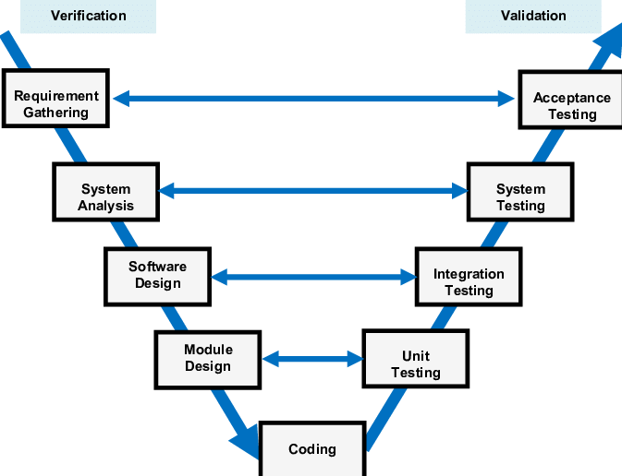

**System  Architecture:**

**Client-Server Architecture:**

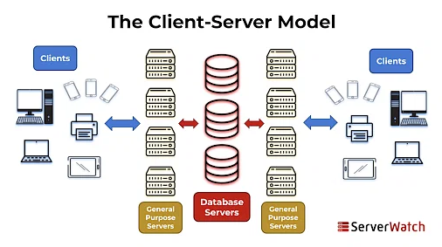

The sports management system will utilize a client-server architecture, where the client-side consists of web browsers (such as Google Chrome, Mozilla Firefox) that interact with the server-side implemented using PHP and XAMPP. The server-side will handle requests, process data, and communicate with the database for data storage and retrieval. The client-side will render the user interface and interact with the server via HTTP requests.

**Use Case Diagram:**

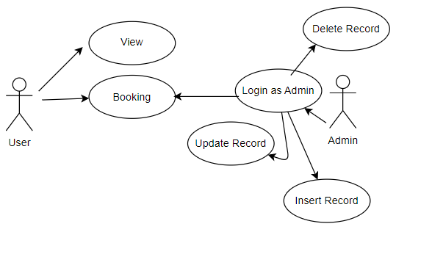

**Sequential Diagram:**

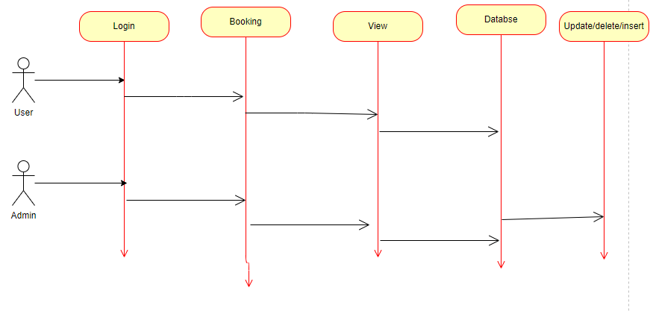

**Snapshots:**







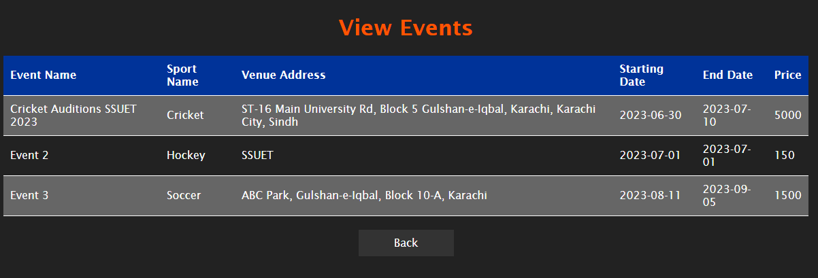

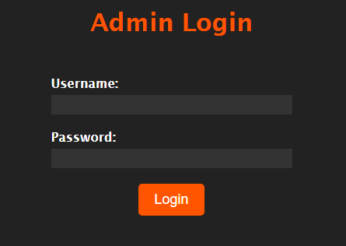

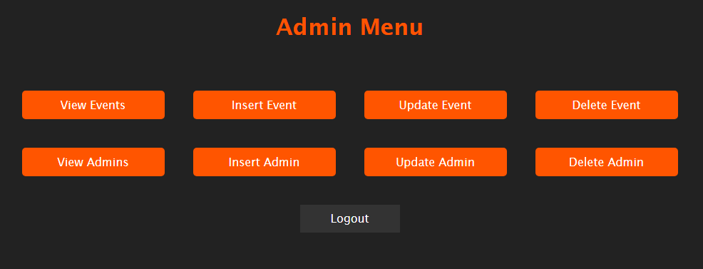

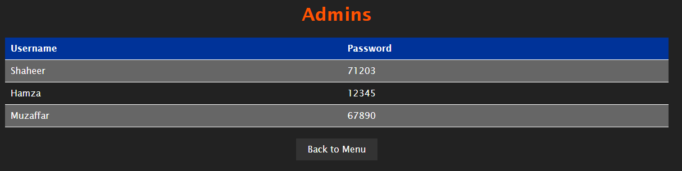

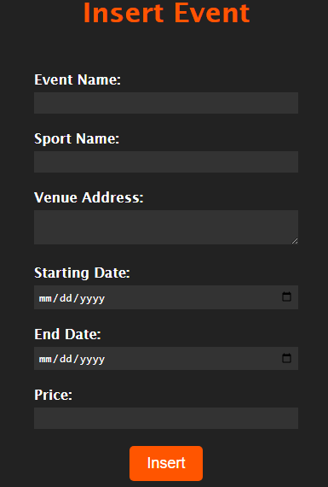

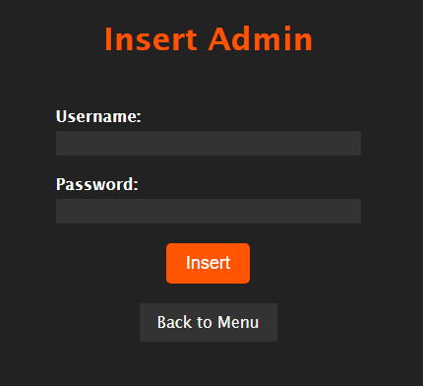

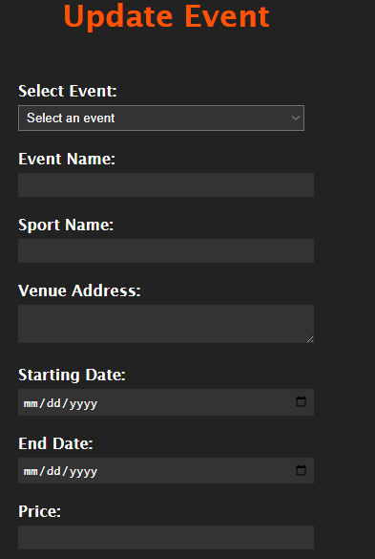

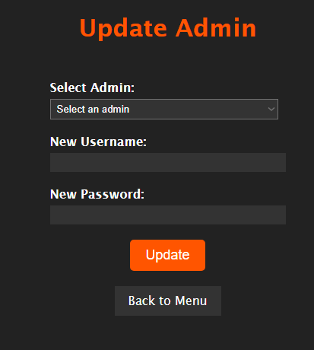

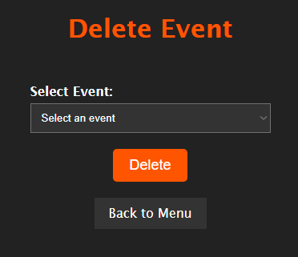

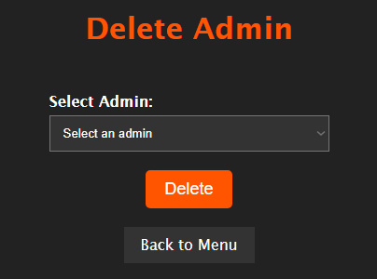

**Database:**

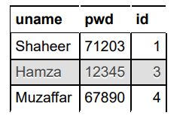

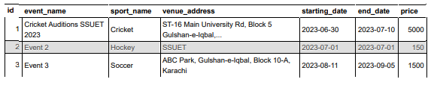

**Conclusion:**